Experiment 2
Design of Bus booking system Prototype using Figma
Sketch a Simple Prototype of a Bus Ticket Booking System using Figma Tool

Procedure
Step 1: Creating a new frame using the Frame tool (F) and selecting iPhone Plus layout.
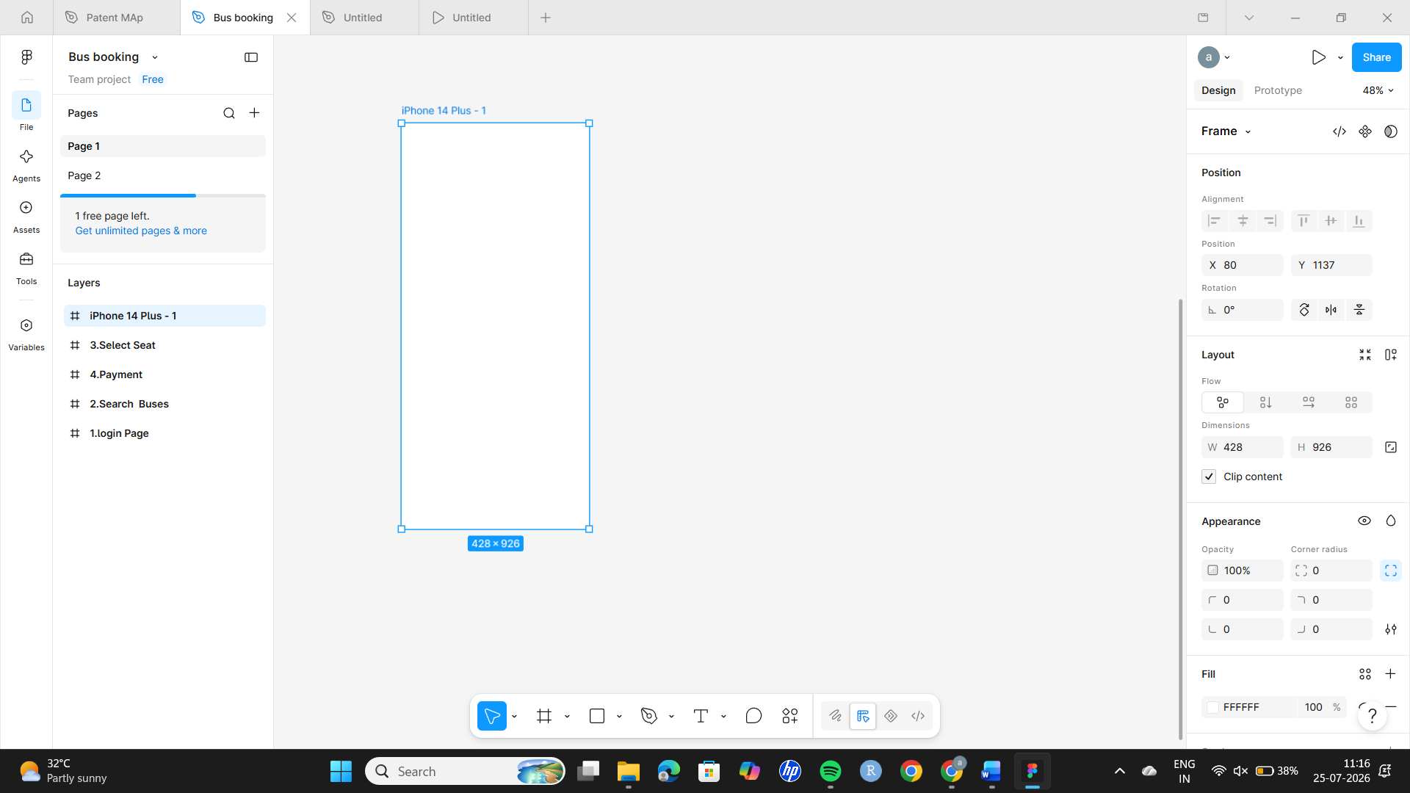
Step 2: Adjusting frame layout and alignment for mobile UI standards.
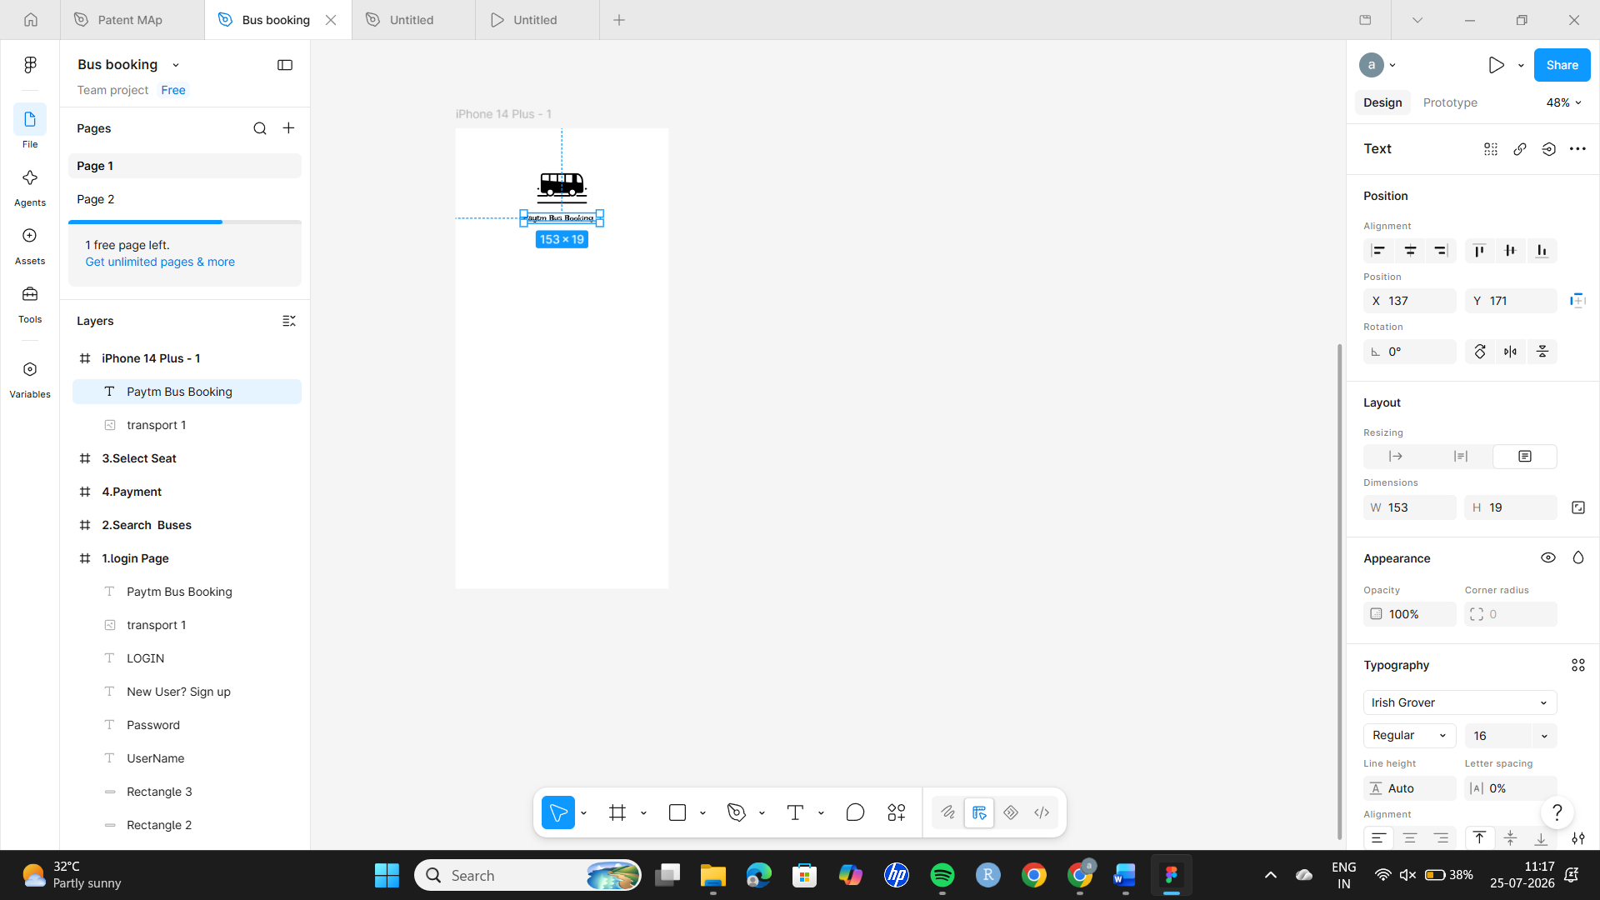
Step 3: Inserting icons to enhance usability and design.
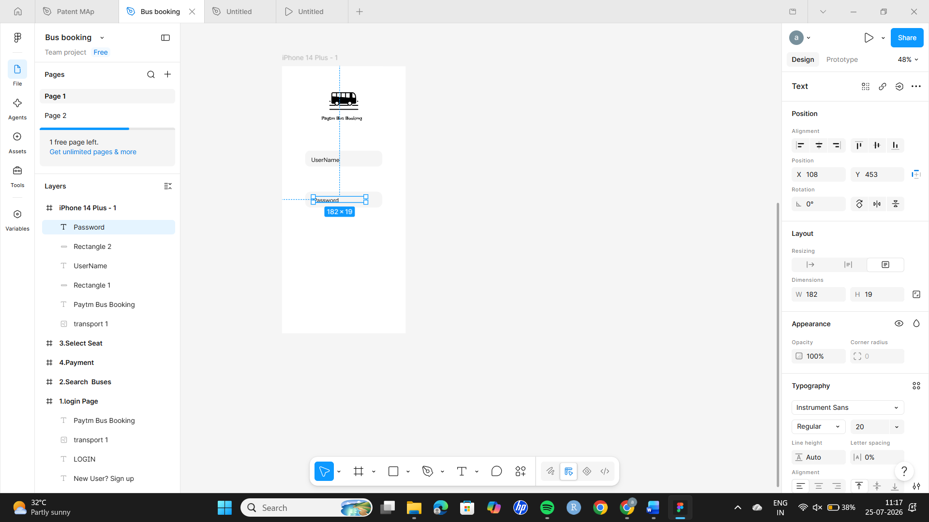

Step 5: Adding text elements using the Text tool (T).
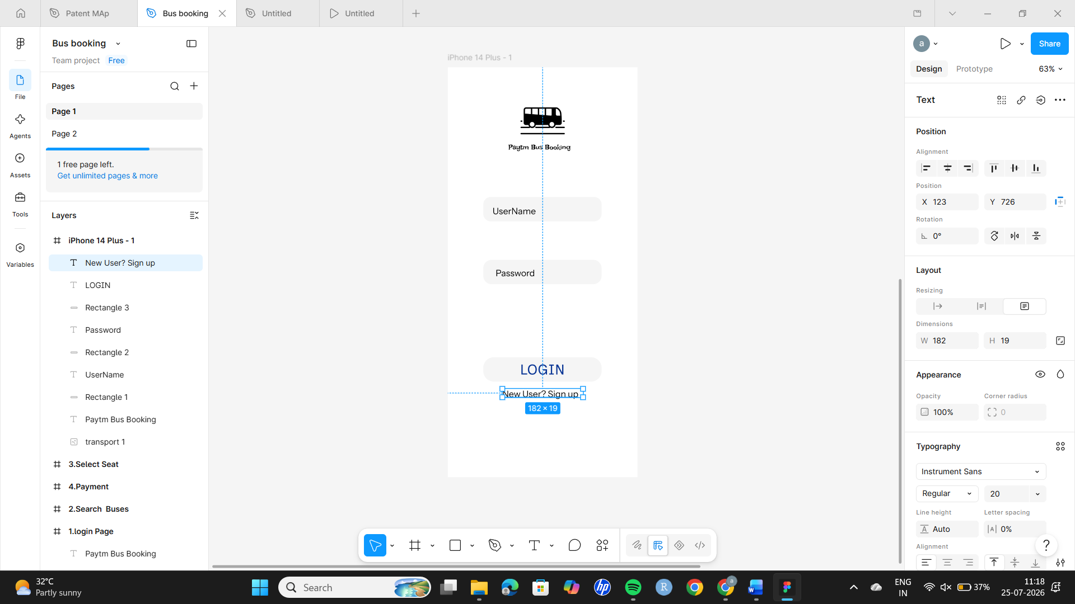
Step 6: Creating multiple screens using additional frames.
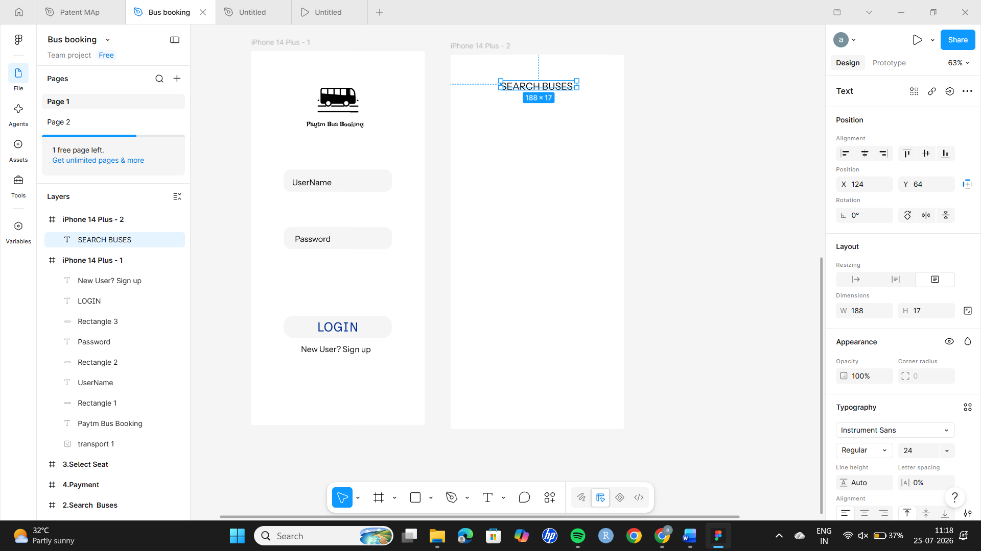
Step 7: Adding UI components like buttons and icons.
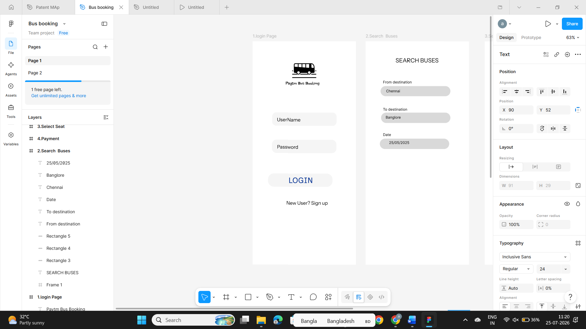
Step 9: Enhancing design with colors, spacing, and corner radius.
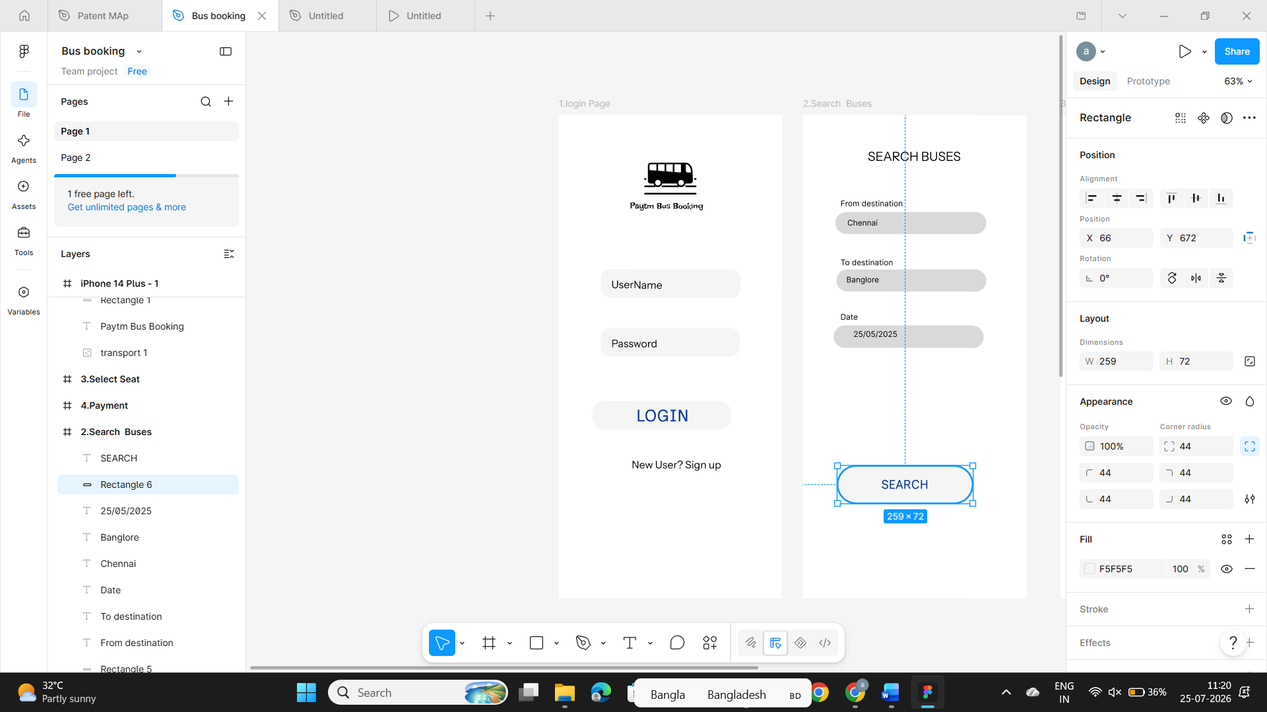

Step 10: Creating another screen and adding icons from flat icom website and texts and buttons
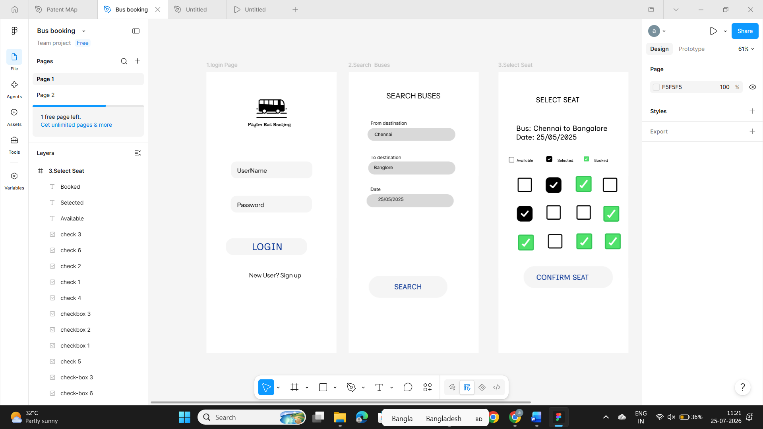
Step 11: Create another frame using text box add texts and buttons
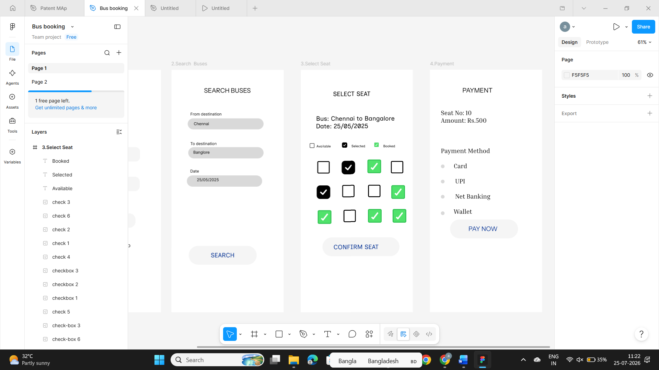
Step 12. Connect each screens using prototype drag and touch
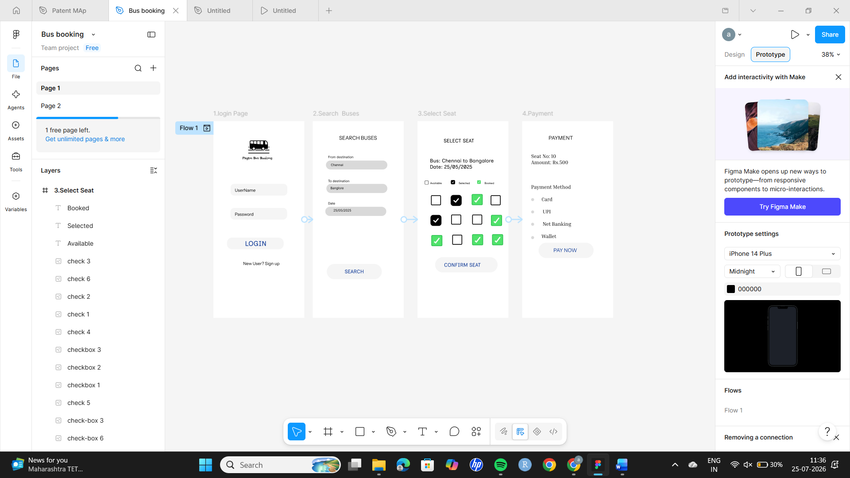

Output
A complete and interactive prototype of an E-Commerce mobile application is successfully created using Figma.

